1.What is cloud computing?
Cloud computing is the on-demand delivery of computing services—including servers, storage, databases, networking, and software—over the internet. It eliminates the need to buy and maintain physical data centers, allowing individuals and businesses to access scalable resources and pay only for what they use.
Architecture
Cloud computing architecture refers to the components and sub-components required for cloud computing. These components typically refer to:
- Front end ( Fat client, Thin client)
- Back-end platforms ( Servers, Storage )
- Cloud-based delivery and a network ( Internet, Intranet, Intercloud)
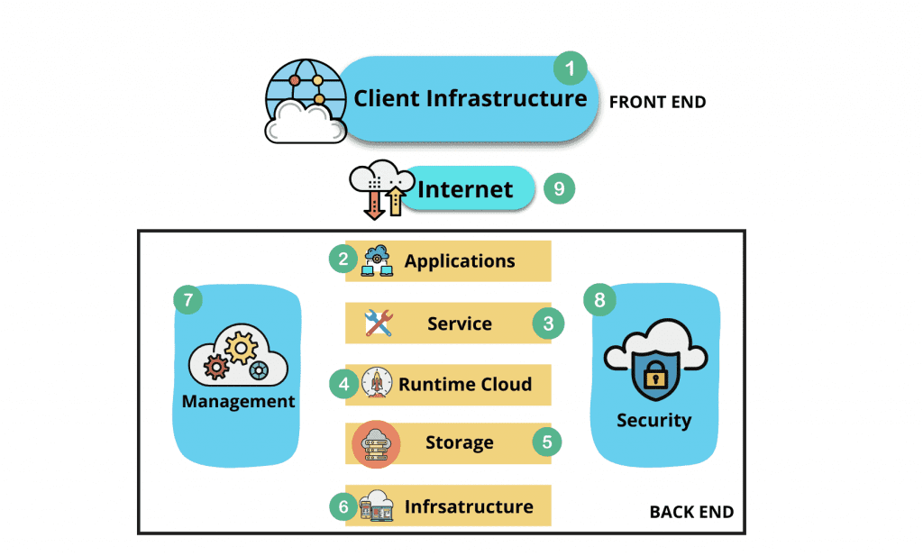
- Front End (User Interaction Enhancement): Includes user interfaces and client devices. Thin clients use web browsers for simple access, while fat clients provide advanced features and a better user experience.
- Back-End Platforms (Cloud Computing Engine): Consists of servers and storage systems that handle data processing, application management, and data storage in the cloud.
- Cloud-Based Delivery and Network: Provides access to cloud services through the Internet, Intranet, and Intercloud for smooth communication, connectivity, and data transfer.

Characteristics
All cloud services share five fundamental characteristics that define them:
- On-Demand Self-Service: Users can create and manage resources anytime without provider support.
- Broad Network Access: Cloud services can be accessed from anywhere using devices like laptops and phones.
- Resource Pooling: Resources are shared among multiple users and assigned as needed.
- Rapid Elasticity: Resources can quickly scale up or down based on demand.
- Measured Service: Users pay only for the resources they use.

2. Advantages of Microsoft Azure
Microsoft Azure is a leading cloud platform providing scalable computing, storage, AI, and analytics. Its main advantages include cost-efficiency (pay-as-you-go pricing), industry-leading compliance, seamless hybrid cloud capabilities, and robust disaster recovery.
Core Advantages
- Cost Efficiency: Pay-as-you-go pricing model eliminates massive upfront hardware investments. You only pay for the exact resources your business consumes.
- On-Demand Scalability: Azure allows organizations to easily scale compute, storage, and networking resources up or down to match real-time demand.
- Robust Security & Compliance: The platform provides multilayer security and meets over 90 regulatory compliance standards, including HIPAA, GDPR, and ISO.
- Seamless Hybrid Cloud: Azure offers unrivaled hybrid flexibility using tools like Azure Arc and Azure Stack, integrating local on-premises data centers with the public cloud.
- Disaster Recovery & Redundancy: Automatic backups and redundant global data centers minimize downtime and protect against critical data loss.

3.What is hosting in Azure?
Hosting in Azure means renting Microsoft’s global server infrastructure to run your applications, websites, databases, and files instead of using local, on-premises hardware.
Instead of buying and maintaining physical servers, you deploy your code to Microsoft’s data centres. Azure handles the hardware upkeep, power, security, and networking.
Core Hosting Models
Azure categorises its hosting environments based on how much infrastructure management you want to handle:
- Infrastructure as a Service (IaaS): You rent a clean virtual server (Azure Virtual Machines). You are responsible for installing the operating system patches, web servers, and runtime environments. This offers maximum control.
- Platform as a Service (PaaS): You upload only your application code or containers (Azure App Service or Container Apps). Azure manages the OS, web server configuration, automatic scaling, and security patches.
- Serverless Hosting: You write individual blocks of code (Azure Functions). They only run and consume budget when triggered by an event, such as an API request or a file upload.
4. IaaS (Infrastructure as a Service)
You rent the raw physical hardware, networking, and storage components as virtualized resources.
- The Division: Azure manages the physical data center, power, cooling, and virtualization layers. You must manage the operating system, runtime, security patches, databases, and application code.
- Azure Example: Azure Virtual Machines (VMs). You spin up a blank Windows or Linux server and configure everything yourself.
- Best For: Migrating legacy applications to the cloud exactly as they are configured on-premises.
PaaS (Platform as a Service)
Azure provides a pre-configured hardware and software platform, allowing you to focus entirely on building apps.
- The Division: Azure handles the operating system updates, hardware scaling, networking rules, and middleware. You only manage your application code and the data it uses.
- Azure Example: Azure App Service or Azure Functions. You upload code (like a Python API or a Node.js website), and Azure instantly runs it.
- Best For: Software developers who want to deploy web apps and APIs quickly without managing server upkeep.

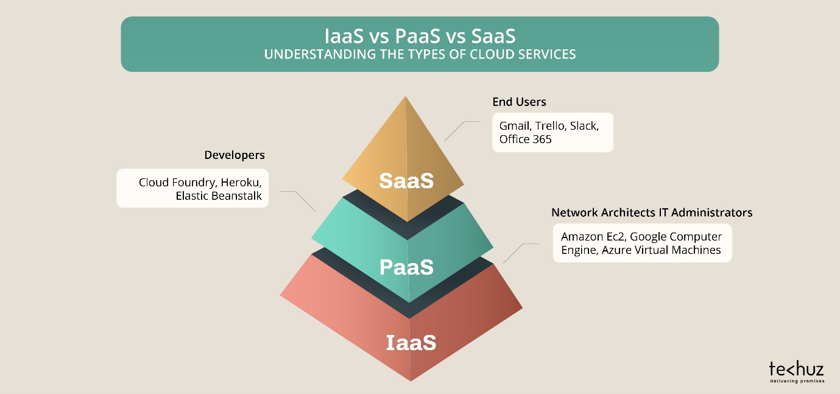
SaaS (Software as a Service)
You use a fully functioning, end-user application hosted and managed entirely by the service provider over the internet.
- The Division: The cloud provider manages the entire stack from the physical servers up to the user interface. You only manage your user accounts and application configuration settings.
- Microsoft Example: Microsoft 365 (Word, Excel online) or Microsoft Dynamics 365.
- Best For: Standard business applications like email, customer relationship management (CRM), and productivity suites.

